**Lesson 8 Demo 2**

**Publish Test Cases Reports in Jenkins**

**Objective:** Configure a Freestyle Jenkins job to integrate Maven Build Tool and Unit Test Cases.

**Tools required:** Jenkins

**Pre-requisites:** You need to have a Jenkins up and running.

Steps to be followed:

1. Log in to Jenkins CI tool and configure freestyle job to run maven Build and Unit Test cases.

**Step 1: Log in to Jenkins CI tool and configure freestyle job to run maven Build and Unit Test cases.**

1. Login to Jenkins CI tool with admin user and click on New Item to create new Jenkins’s job.

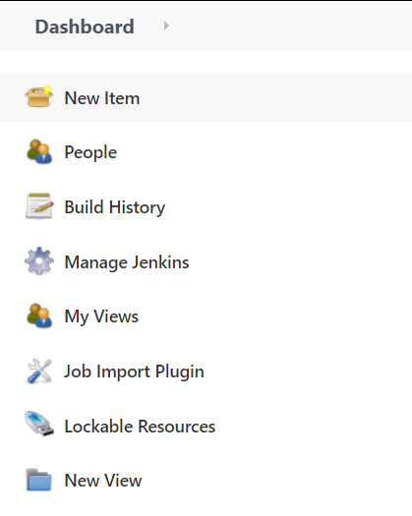

1. Select Freestyle project while creating Jenkins’s job and provide custom job name.

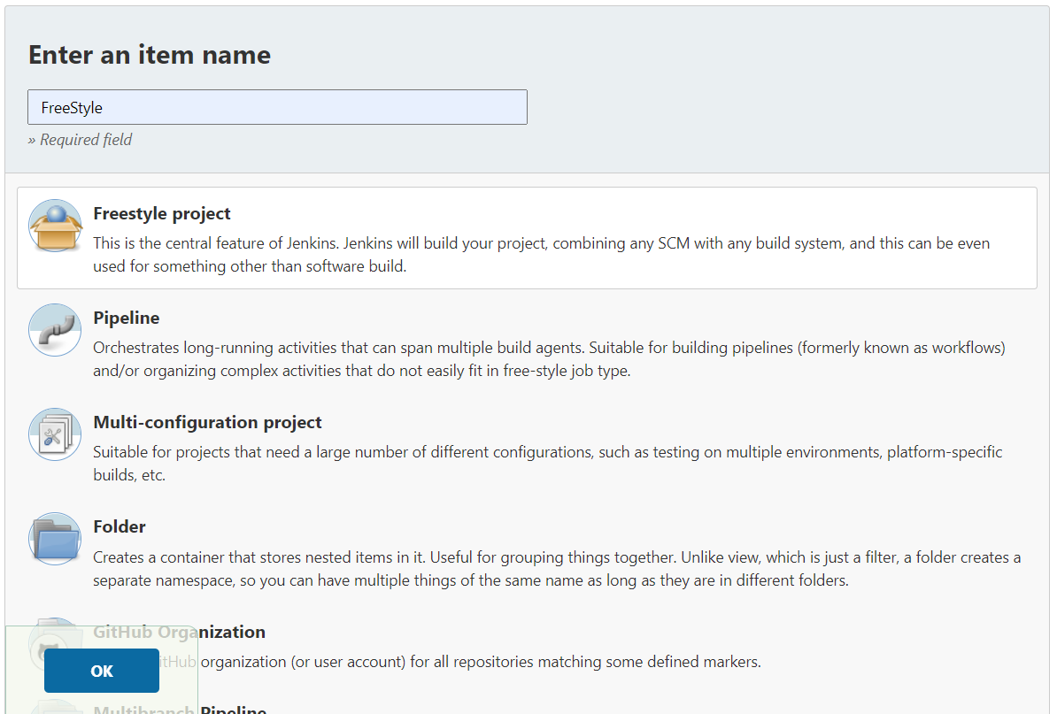

1. Once job name is provided, click on Ok button to save Jenkins’s job and a new configuration screen would be opened.

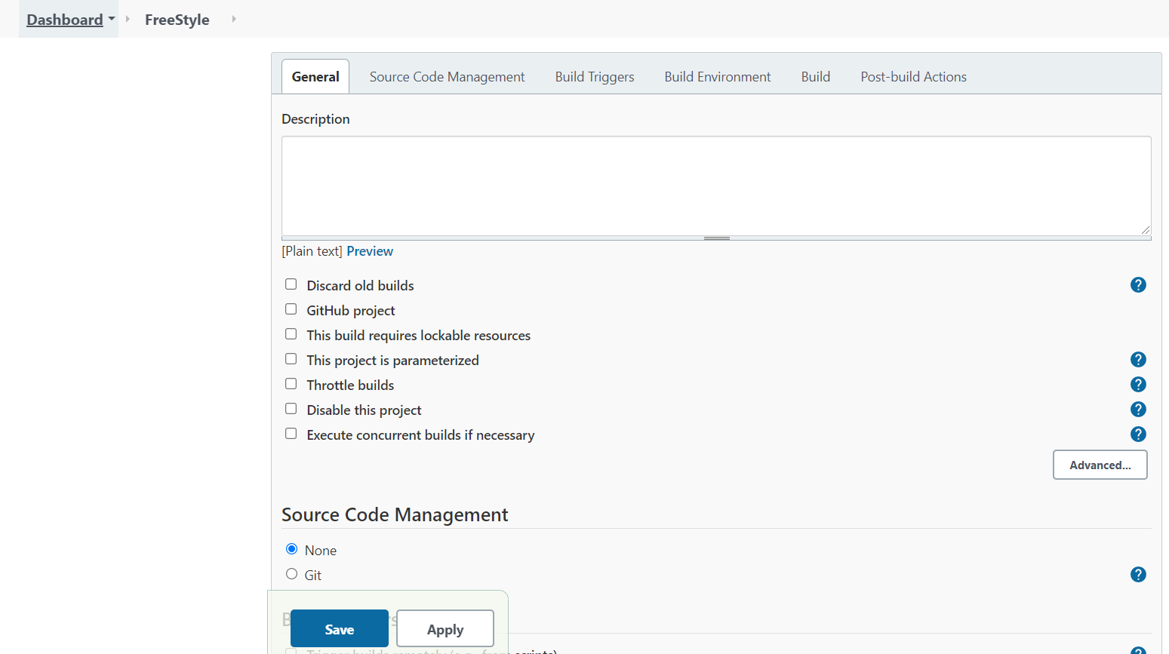

1. In configure screen you need to access Source Code Management tab to provide Git repository configurations.

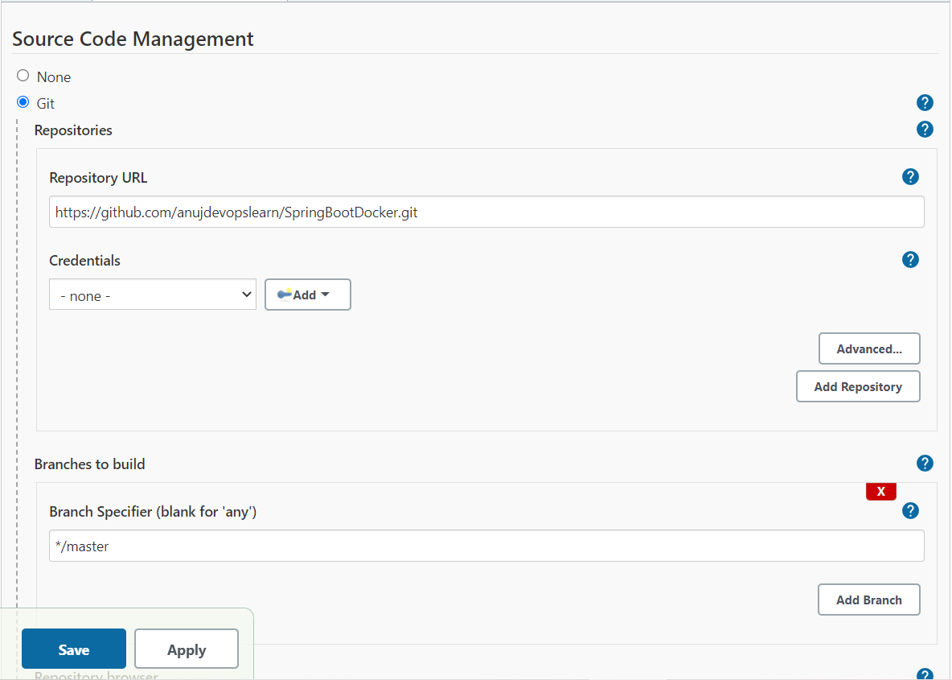

1. Once Git repositories configurations are configured in Jenkins’s job, you can save these configurations in Jenkins.
2. Then configure Maven build step as Build step to execute maven build for performing build automation.

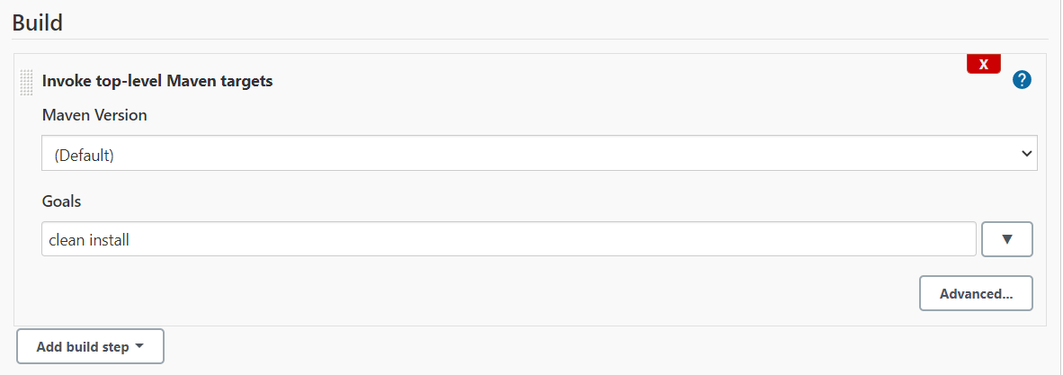

1. Once Maven build process is configured, we can configure Post build action to record unit test cases execution reports by selecting **Publish Junit test results report** in Jenkins.

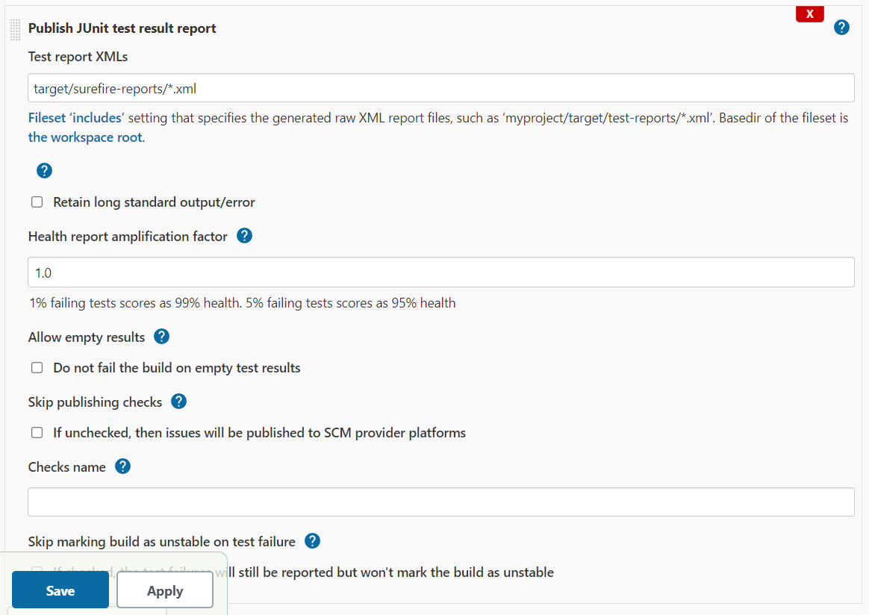

1. Then Click on Build Now option to trigger new build and build logs will show you build process logs.

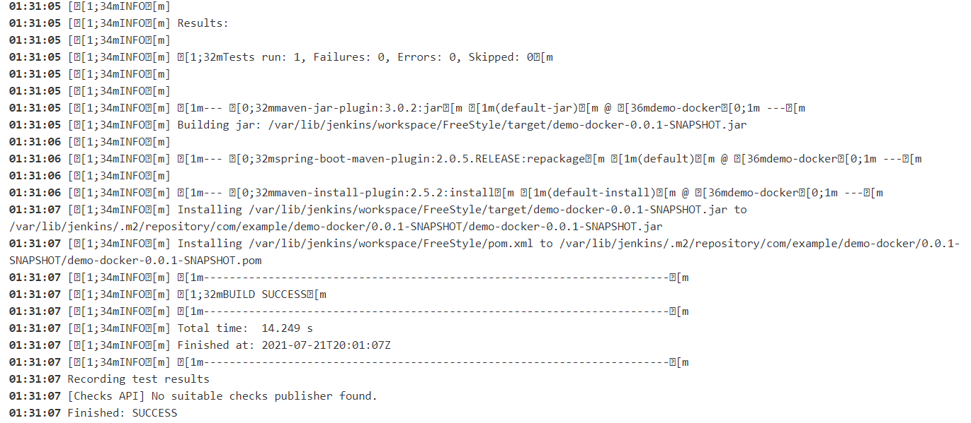

1. Once build is completed, you can check records test results as per below screen:

